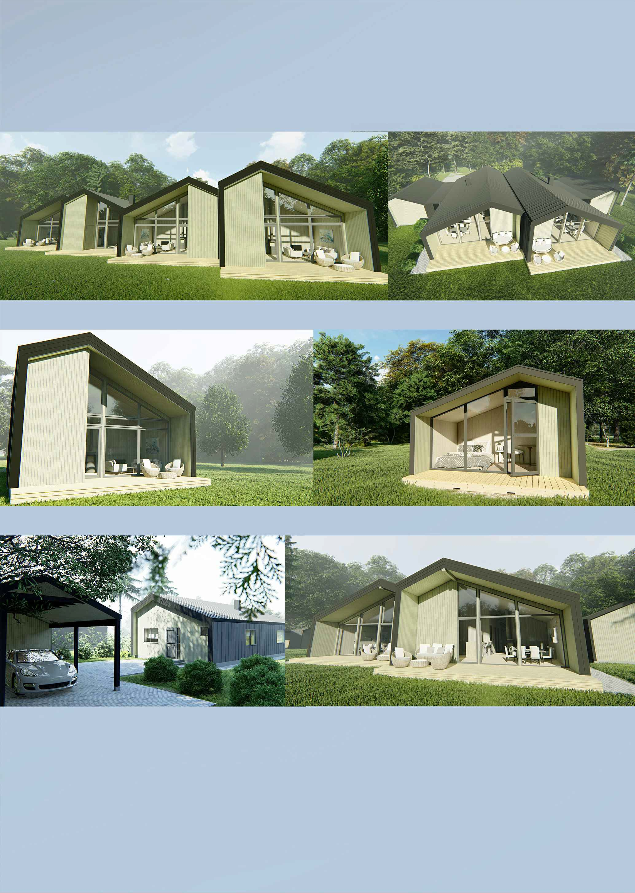
• •

• •

• •

- Y O U • • Y O U I T •

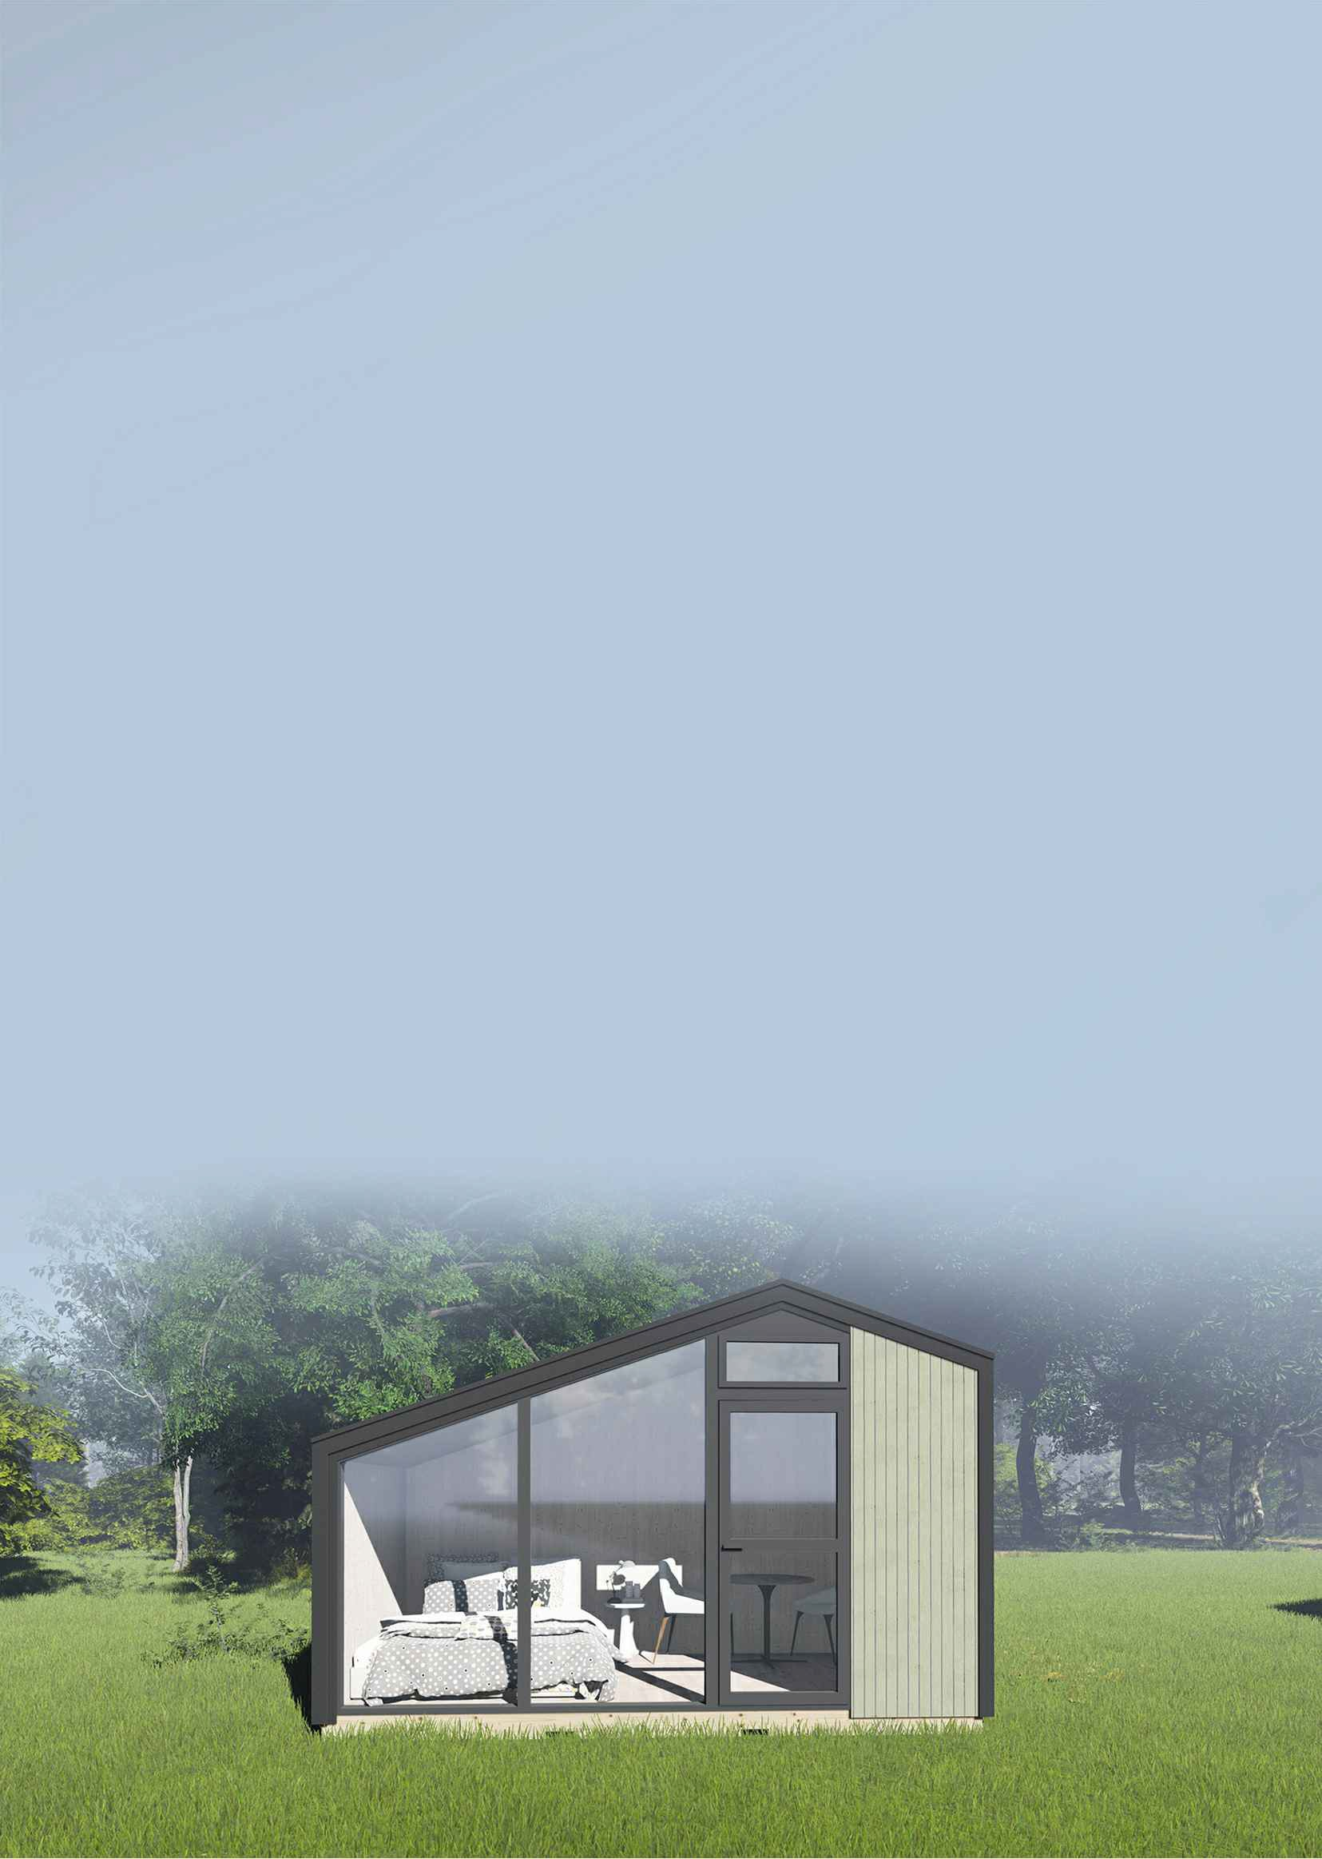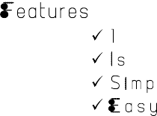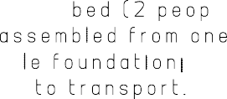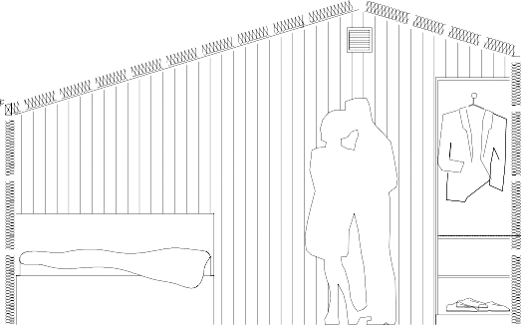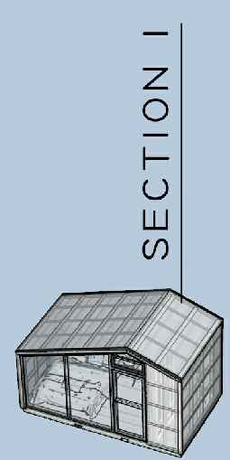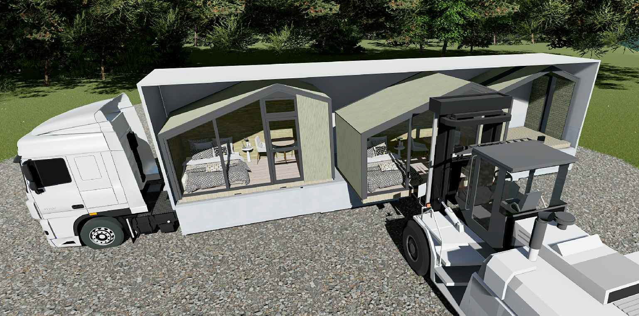

4260

a-a

Bedroom 8,4m2
2400

a-a
.
2946

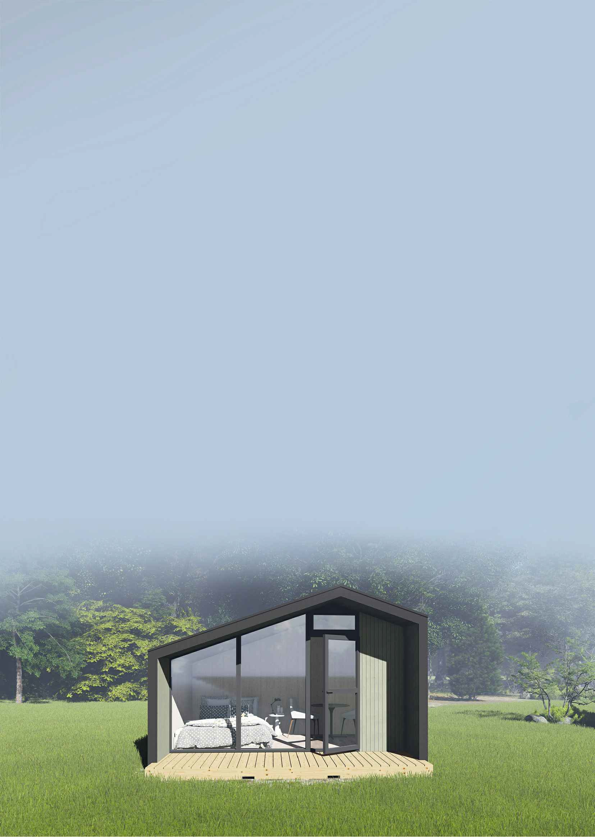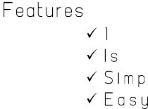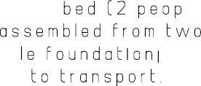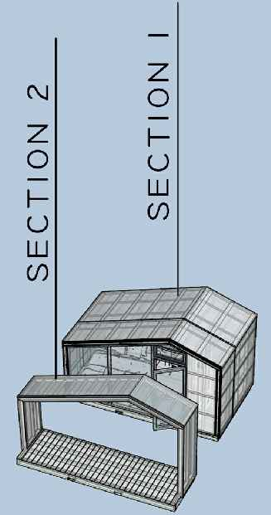

4260

a-a

Bedroom 8,4m2
.
3220

Terrace 4,9m2

a-a
2946

4260

b-b

Bedroom 6,4m2

WC 2,0m2

a-a
.
5920
Living room / kitchen 8,4m2

Terrace 4,9m2

a-a
2946
2946
b-b

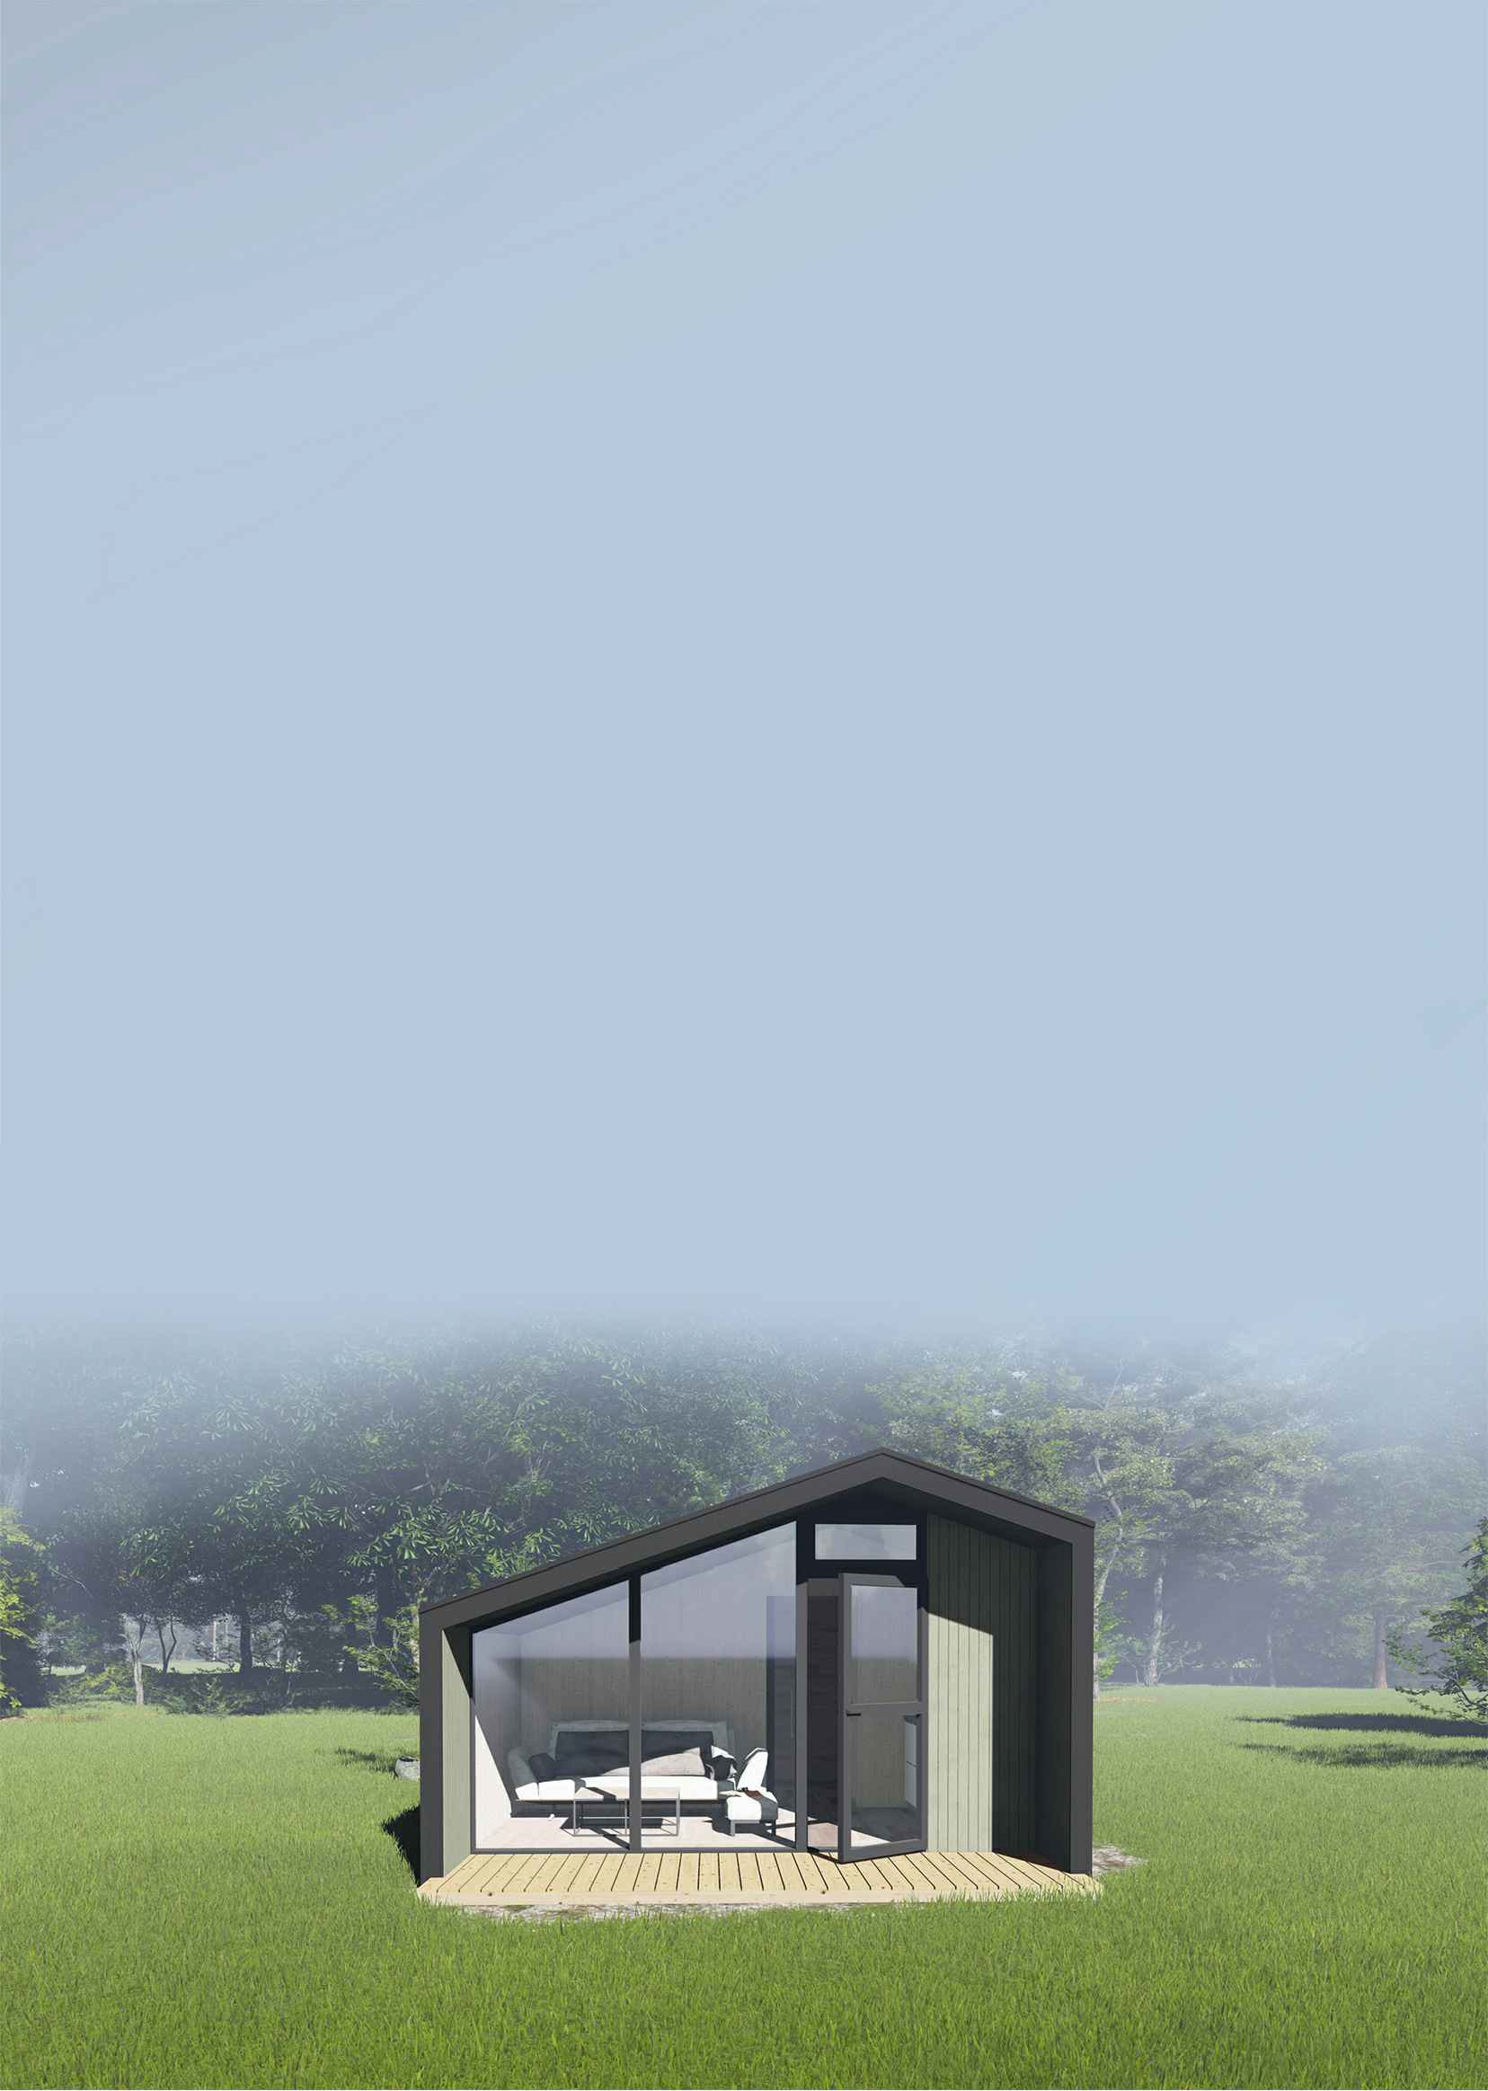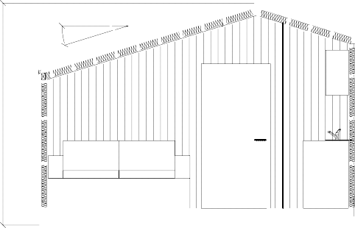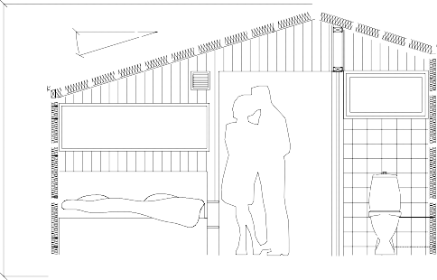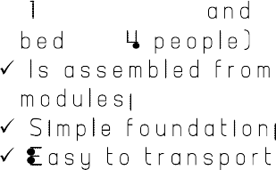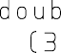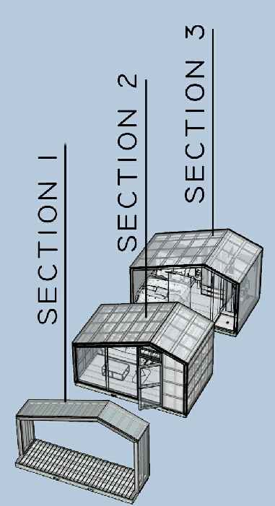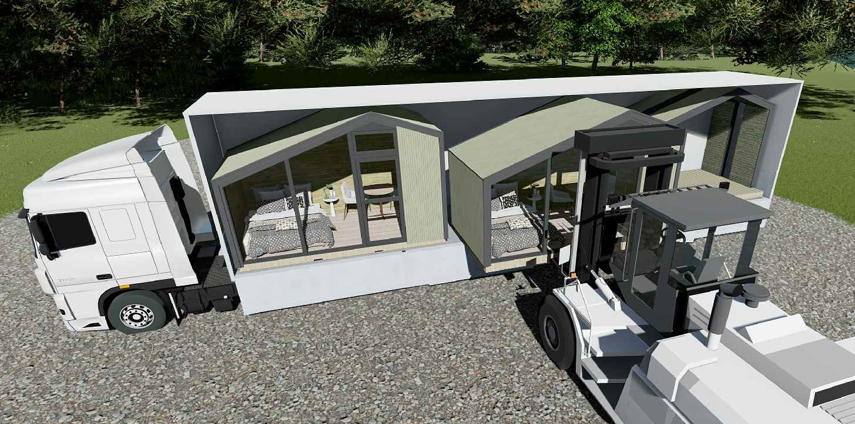

8420

WC 5,lm2

Entrance 5,9m2

Bedroom 6,2m2
4740

. a-a
6740
Living room / kitchen 8,4m2

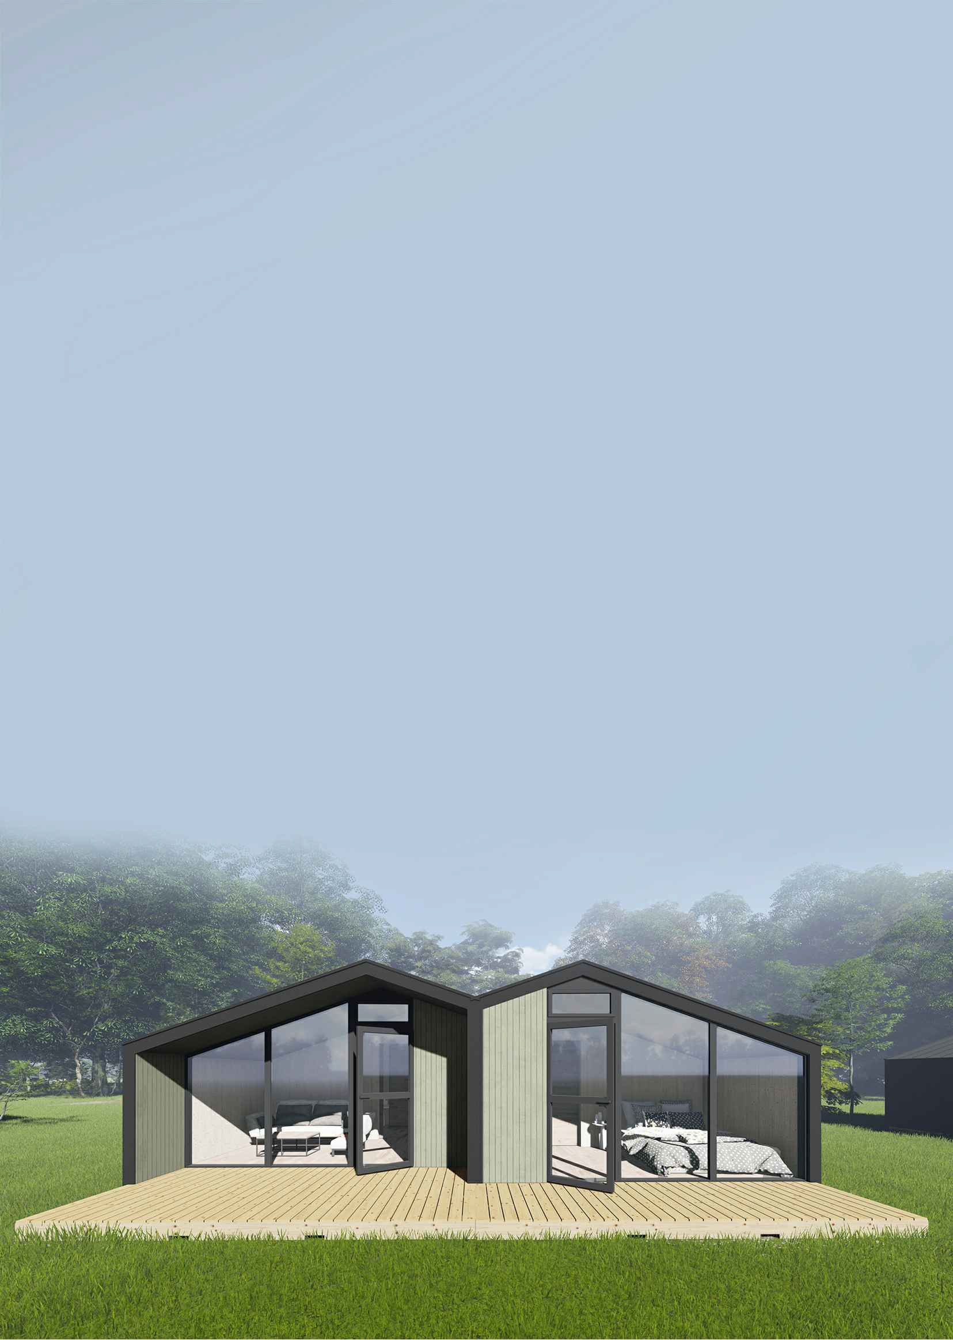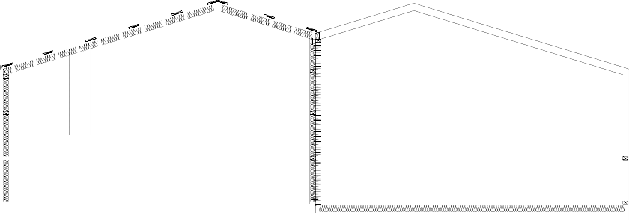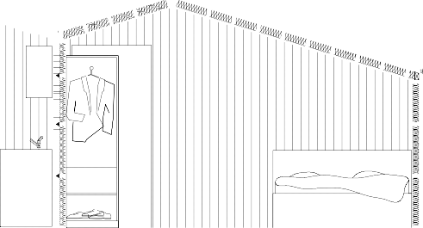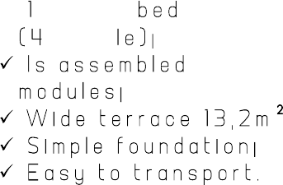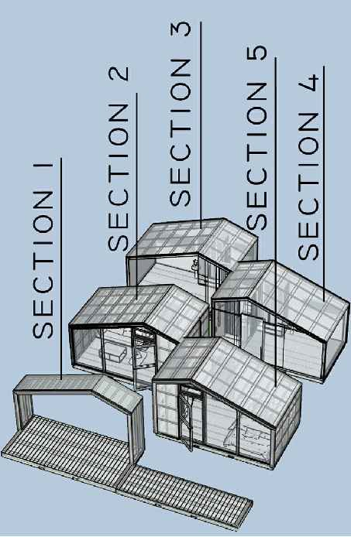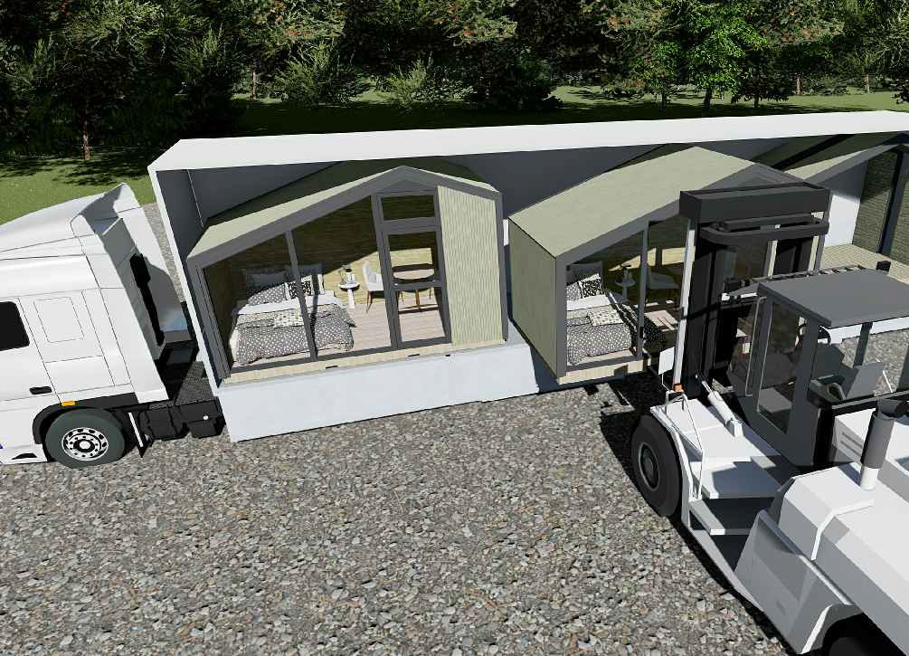Bedroom 8,4m2

Terrace l3,2m2

a-a
2946

1stFLOOR
A-A

Features:

2doublebeds,1singlebedand1bunkbed (7people);
Possibilitytomakemultiplecottages;
NTA=40m 2(1stfloor);
NTA=17m 2;
BRA=52m 2';
BYA=60m 2.

Terrace 14 m2
7000

Livingroom 13,4m2

Kitchen 5,8m2

Bedroom
9,4m2

Entrance 4,2m2

Bathroom 4,8m2

Storage room 1,7m2

Loft
8500

A-A

A-A

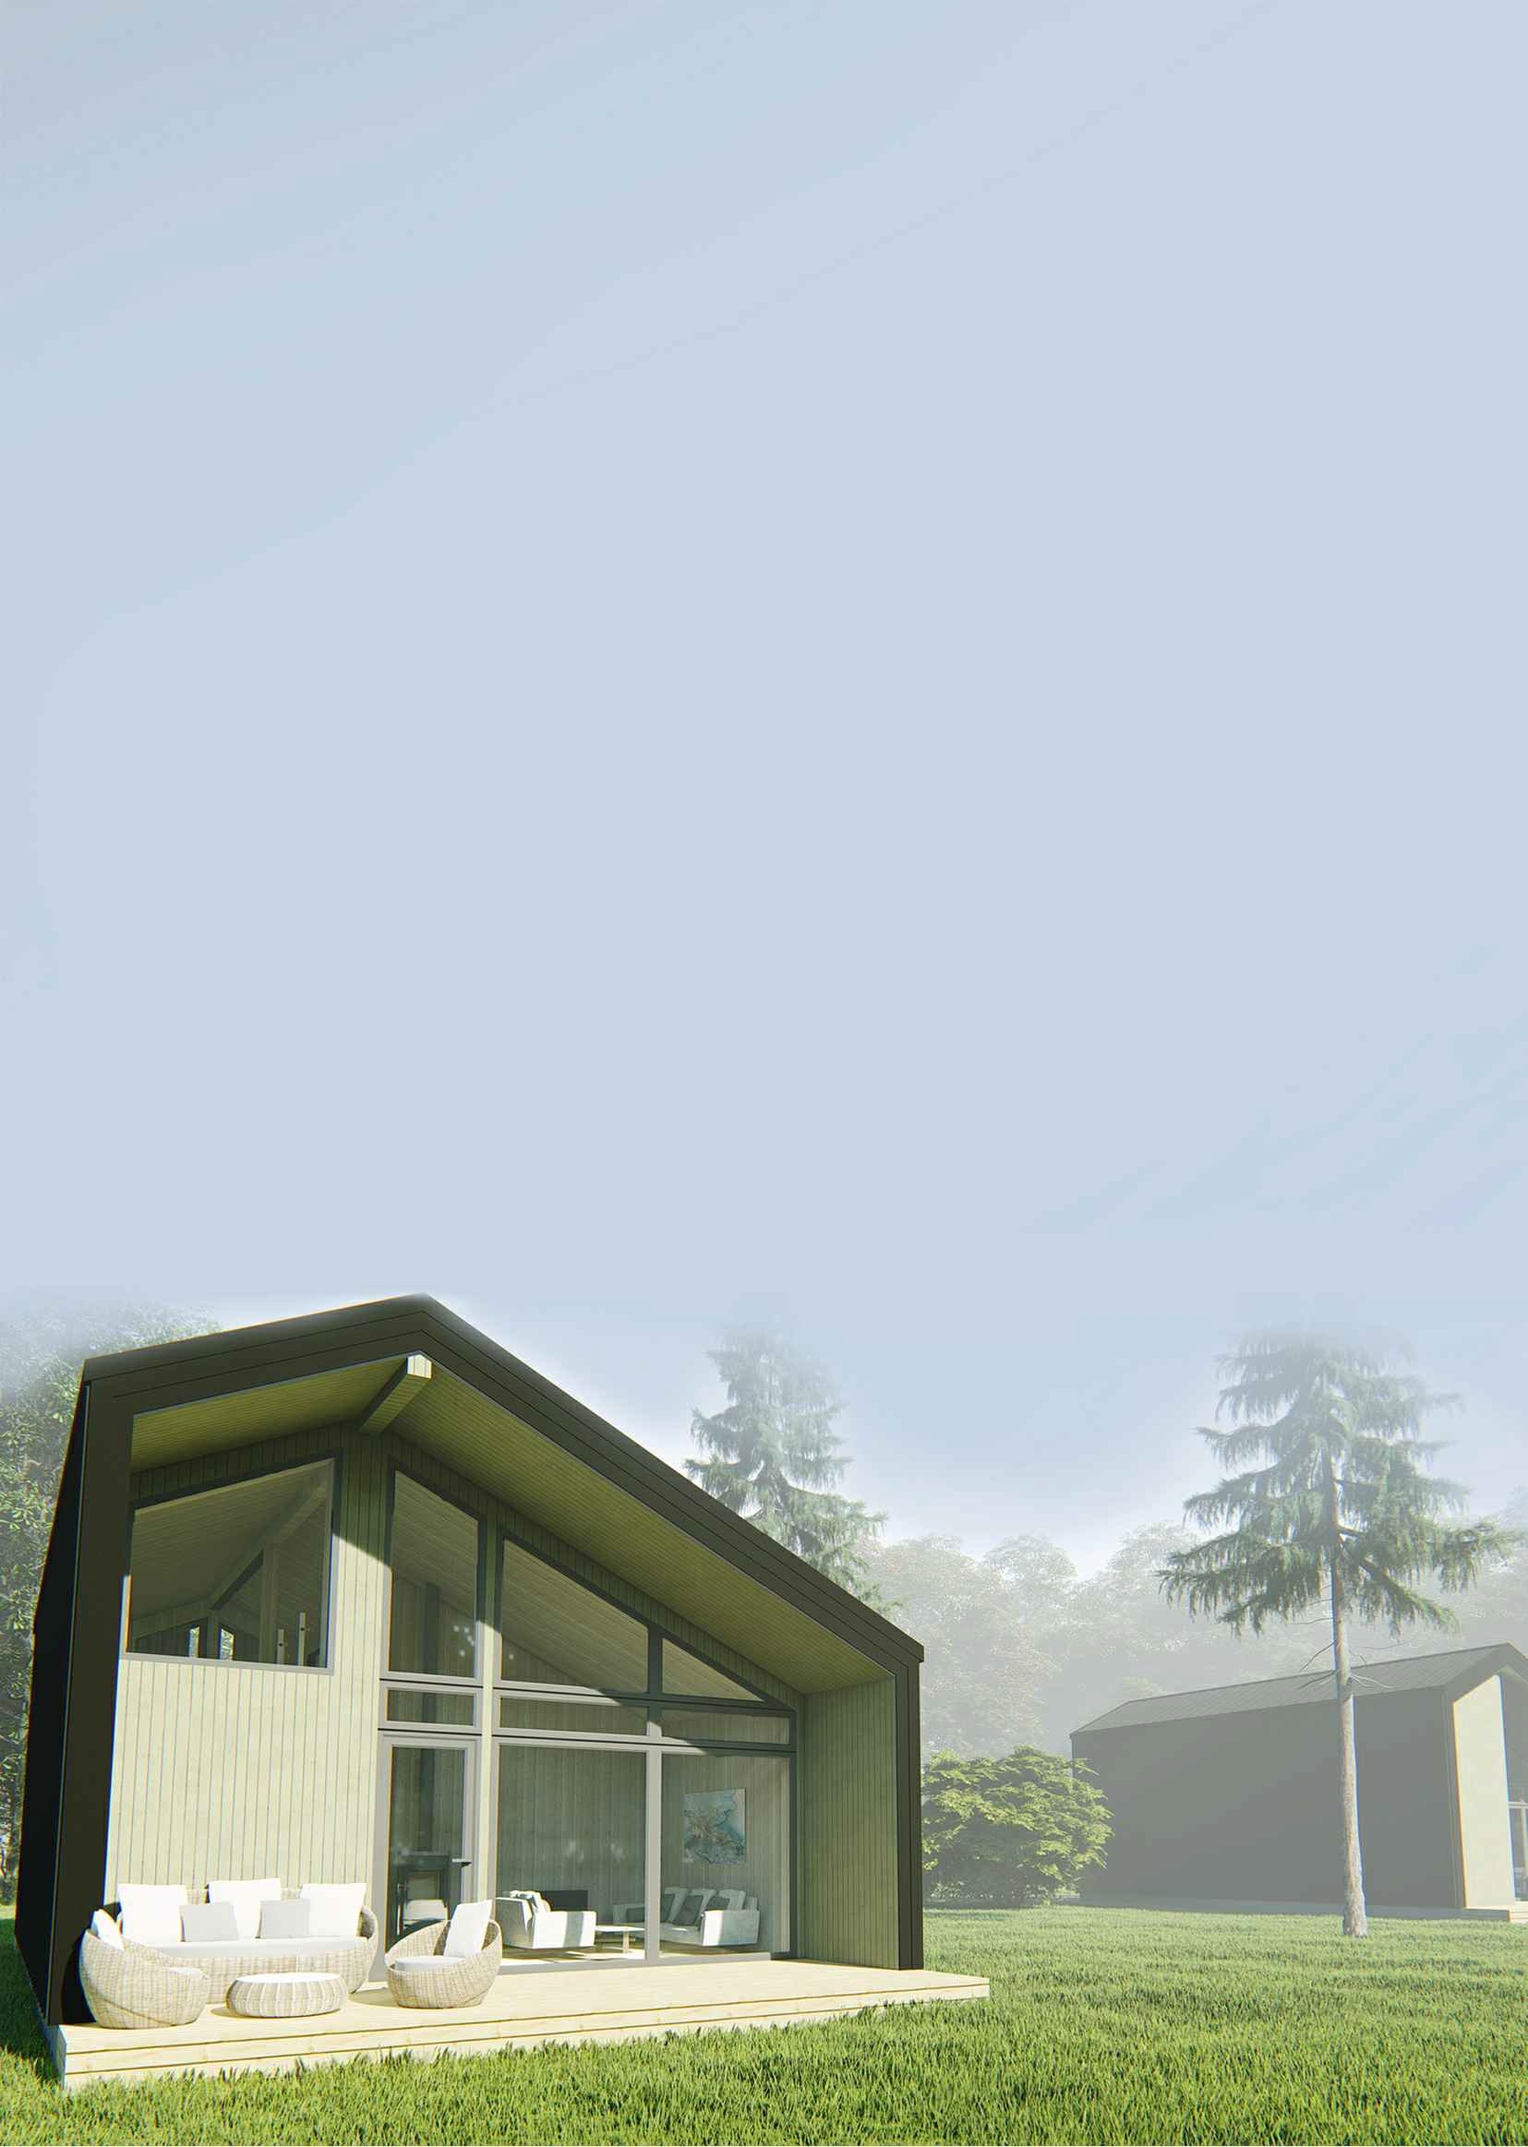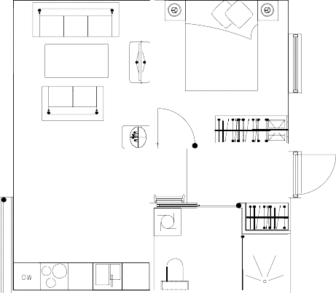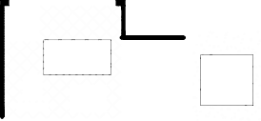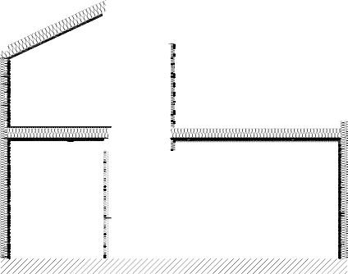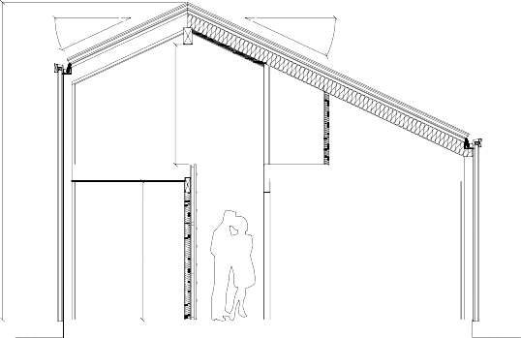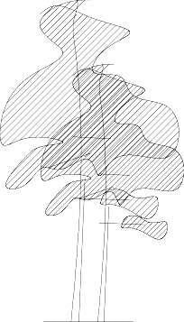

Storage 2,5m2
5268
1992

Loft 14,4m2
2300

A-A

1stFLOOR

A-A

Features:

2doublebeds,1singlebedand1bunkbed(7 people);
Possibilitytomakemultiplecottages;
NTA=40m 2(1stfloor);
NTA=17m 2;
BRA=52m 2';
BYA=60m 2.

Terrace 14 m2
7000

Storage room 2,3m2

Livingroom 13,4m2

Kitchen 5,8m2

DW

8500

A-A

Bedroom
9,4m2

A-A

Entrance 4,2m2

Bathroom 4,8m2

Entrance

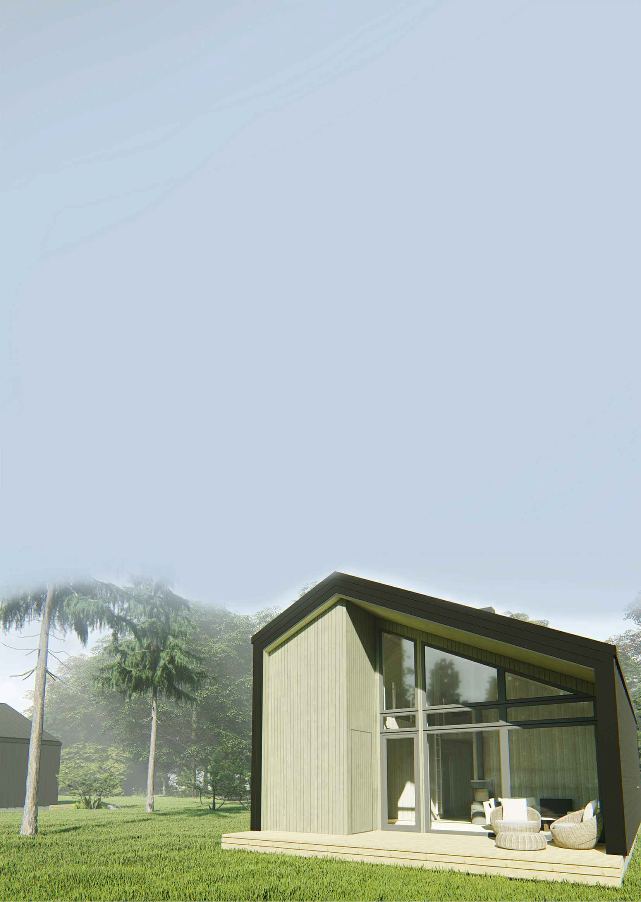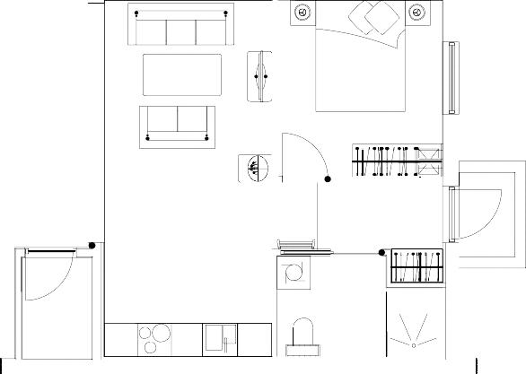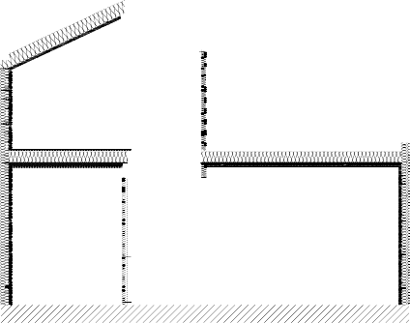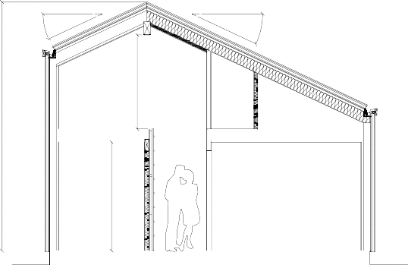Loft A-A

Storage 2,5m2
5268
1992

Loft 14,4m2

A-A
2300

1stFLOOR

A-A

Features:

2doublebeds,1singlebedand 1bunkbed(7people);
Possibilitytomakemultiplecottages;
NTA=52,5m 2(1stfloor);
NTA=17,6m 2;
BRA=70m 2';
BYA=74.3m 2.

Terrace 14 m2
Bedroom
9,0m2
7000
Livingroom 13,4m2

Kitchen S,sm2

DW
Bedroom 6,sm2

Entrance 9,0m2
Bathroom
6,Sm2

Storage room 1,7m2

Loft

A-A

A-A
10600

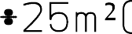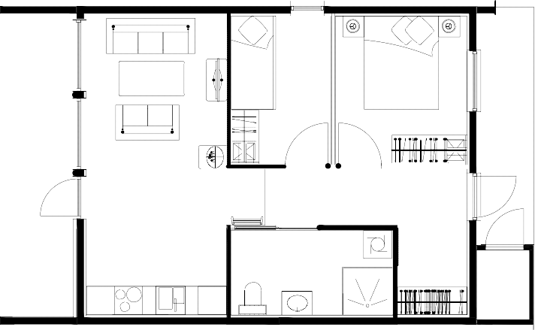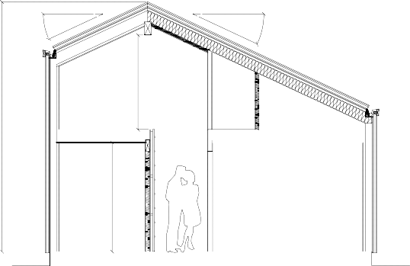

Storage 4,0m2
5268
2300
1992

Loft
21,0m2

A-A

1stFLOOR

A-A

Features:

2doublebeds,1singlebedand 1bunkbed(7people);
Possibilitytomakemultiplecottages;
NTA=52,5m 2(1stfloor);
NTA=17,6m 2;
BRA=70m 2';
BYA=74.3m 2.

Terrace 14 m2
Bedroom
9,0m2
7000

Storage room 2,3m2

Livingroom 13,4m2

Kitchen 5,sm2

DW
Bedroom 6,sm2

Entrance 9,0m2
Bathroom
6,5m2

Entrance

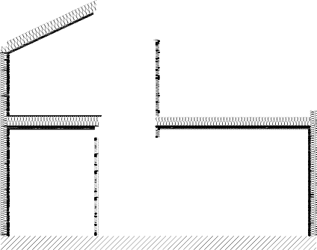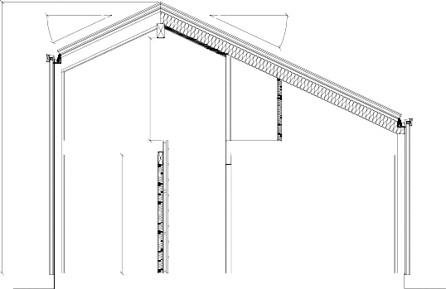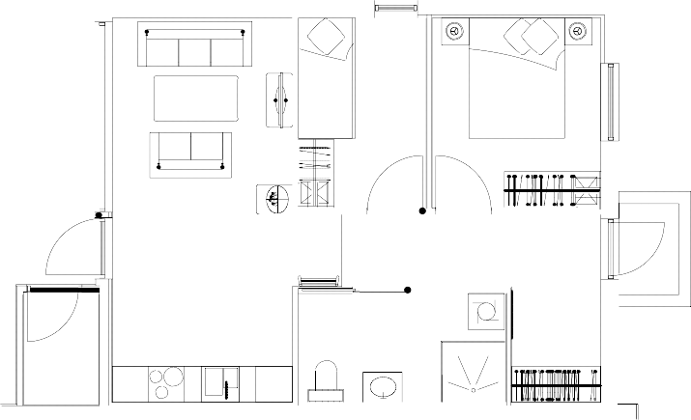A-A 10600

Loft A-A

Storage 4,0m2
5268
1992

Loft
21,0m2

A-A
2300

Features:
3842

2doublebeds(4people);
4614
Possibilitytomakemultiplecottages;
Sideentrance;
Singlefloor;
NTA=80m 2;
BRA=83m 2;
BYA=109m 2_
PLACEFORGARAGE

A-A
Entrance

Livingroom
17,7m2 Storage
4,3 m2

Entrance 4,8 m2
Bedroom 12,0 m2

Terrace 18 m2
7500

Corridor 6,4m2

Kitchen 13,3m2

WC 2,9 m2
Bedroom 12,0 m2
Bathroom 6,5m2

DW

A-A

14500

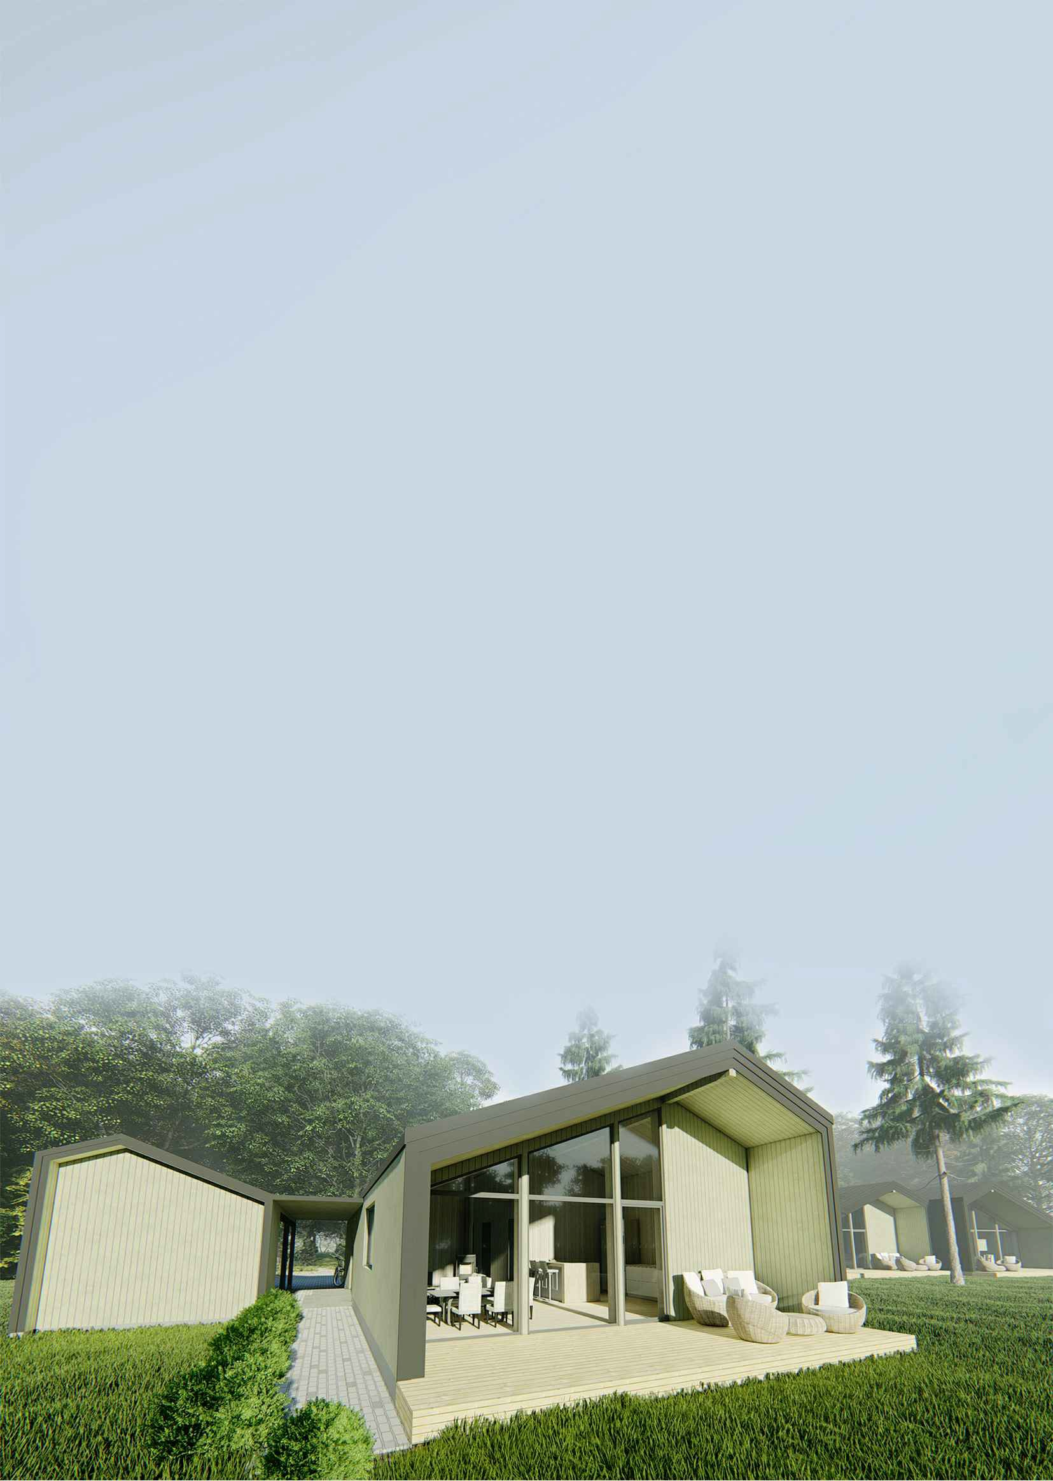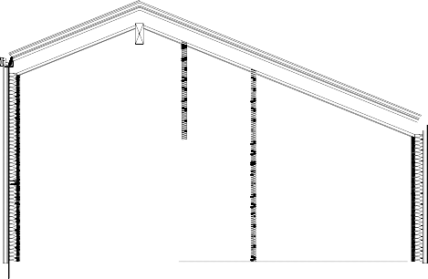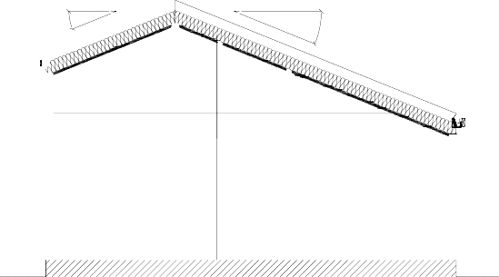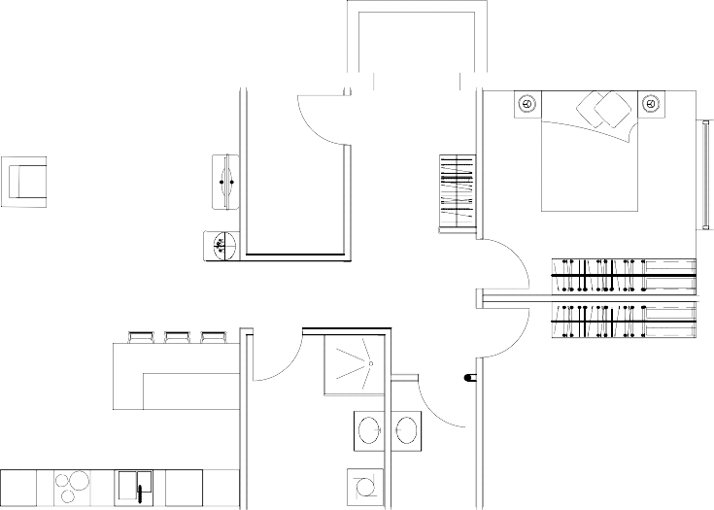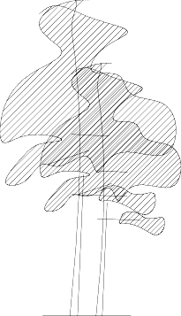

Features:
3842

2doublebeds(4people);
4614
Possibilitytomakemultiplecottages;
Sideentrance;
Singlefloor;
NTA=80m 2;
BRA=83m 2;
BYA=109m 2_

A-A

Livingroom 22,1m2
Storage 4,1m2

Terrace 18 m2
7500

Corridor 4,7m2

Entrance 4,0m2
Bedroom
9,3m2
Entrance

Kitchen 13,3m2
WC
2,4m2
PLACEFORGARAGE

Bathroom 7,2m2
Bedroom 10,8m2

DW

A-A

14500

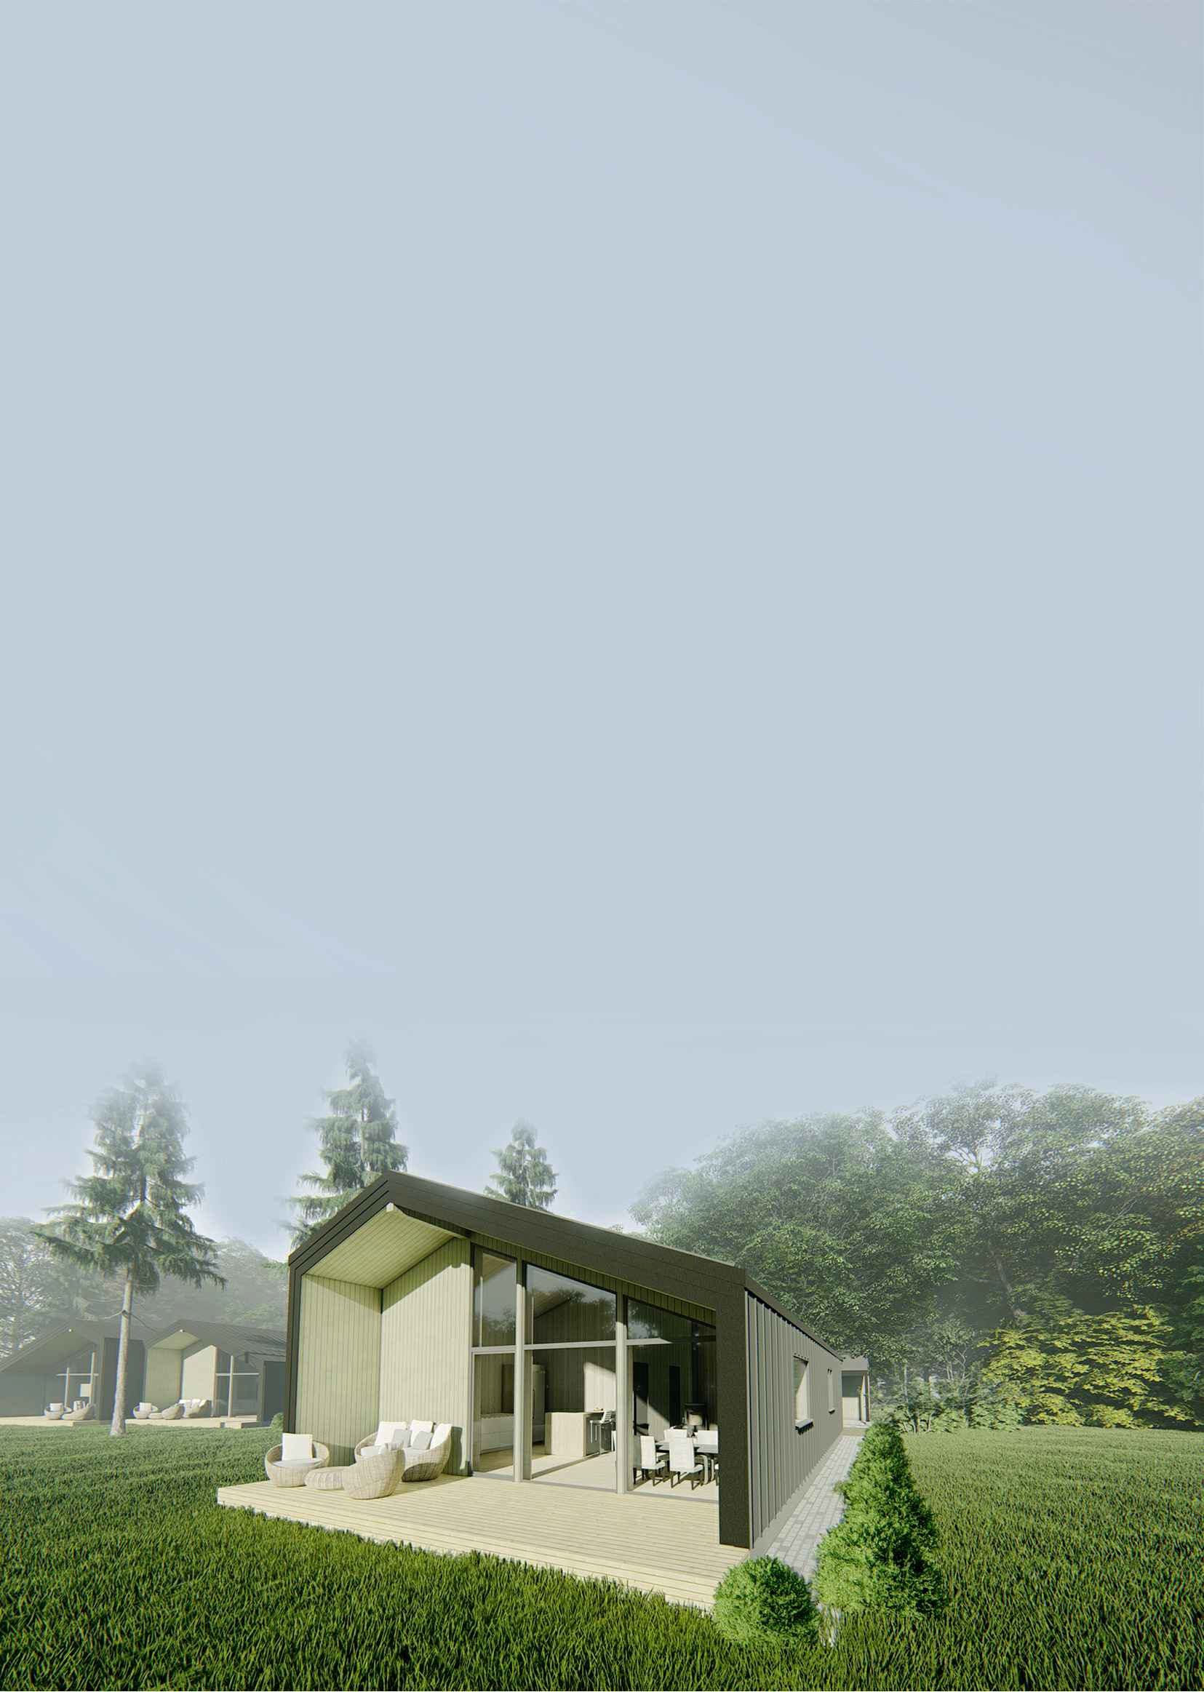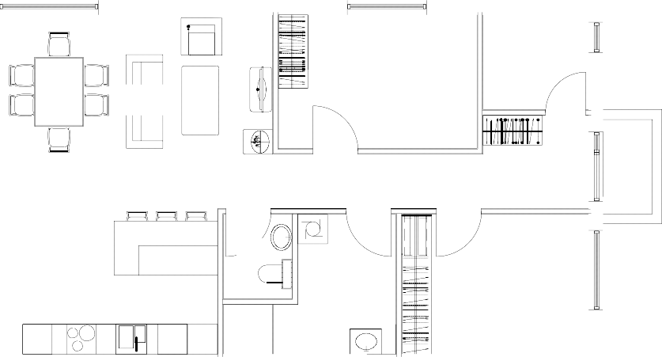

1stFLOOR

A-A
PLACEFORGARAGE

 2doublebeds,2singlebeds
 orbunkbeds(6-8people)
 Possibilitytomakecottages;
 Sideentrance;
 NTA=79,5m (1stfloor);
 NTA=35,5m (2ndfloor);
 BRA=120m ;

Terrace 18 m2
7500

Livingroom 17.7m2

Kitchen 13,3m2
Storage 1,8 m2

Stairs 2,6m2

Bathroom 6,5m2

Entrance 4,8 m2
Entrance

Corridor 6,4m2

WC

Bedroom 12,0 m2

Bedroom 12,0 m2

 BYA=109m .
2,9 m2

DW

14500

A-A

Loft A-A

Storage 2,5m2

Bedroom 10,4m2

Lounge 23,9m2

Bedroom 8,0m2

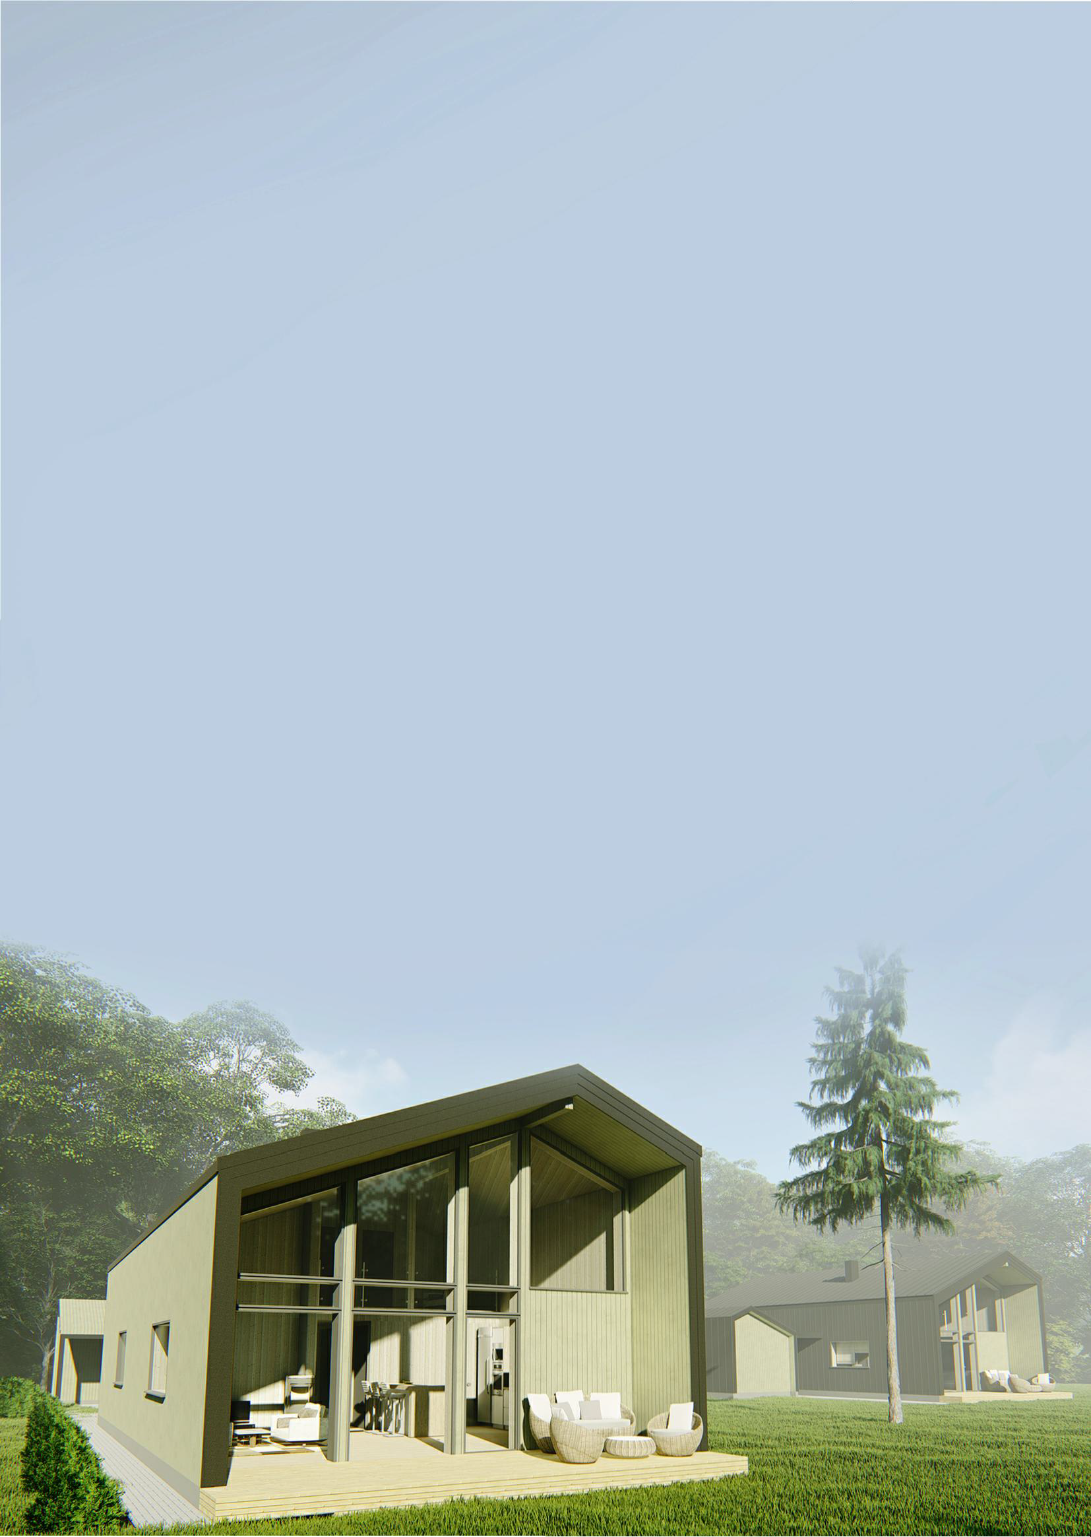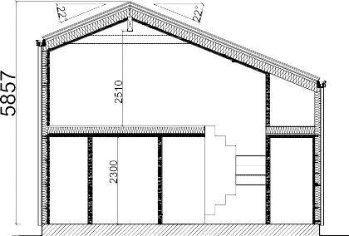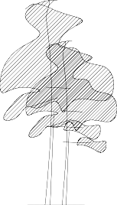

A-A

1stFLOOR

A-A

 2doublebeds,2singlebeds

Livingroom 17,7m2
Closet
1,9m2 Storage
4,1m2
Bedroom
9,3m2

Stairs 2,6m2

orbunkbeds(6-8people)
 Possibilitytomakecottages;
 Sideentrance;
 NTA=79,5m {(1stfloor);
 NTA=35,5m {(2ndfloor);
 BRA=120m {;
 BYA=109m {.

Terrace 18 m2
7500

Kitchen 13,3m2

DW

WC 2,4m2
Bedroom
10,8m2
Corridor 6,0m2

Bathroom 7,2m2

Entrance 4,0m2
Entrance

Loft
14500

A-A
PLACEFORGARAGE

A-A

Storage 2,Sm2

Bedroom 10,4m2

Lounge 23,9m2
Bedroom 8,0m2

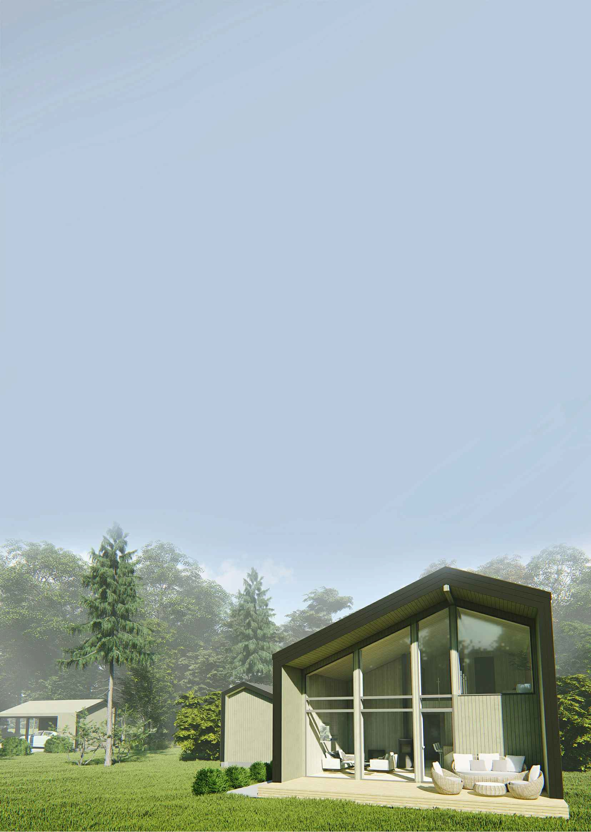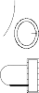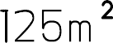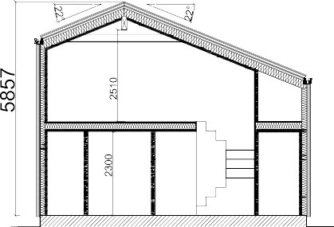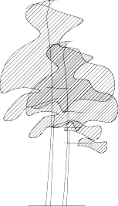

A-A

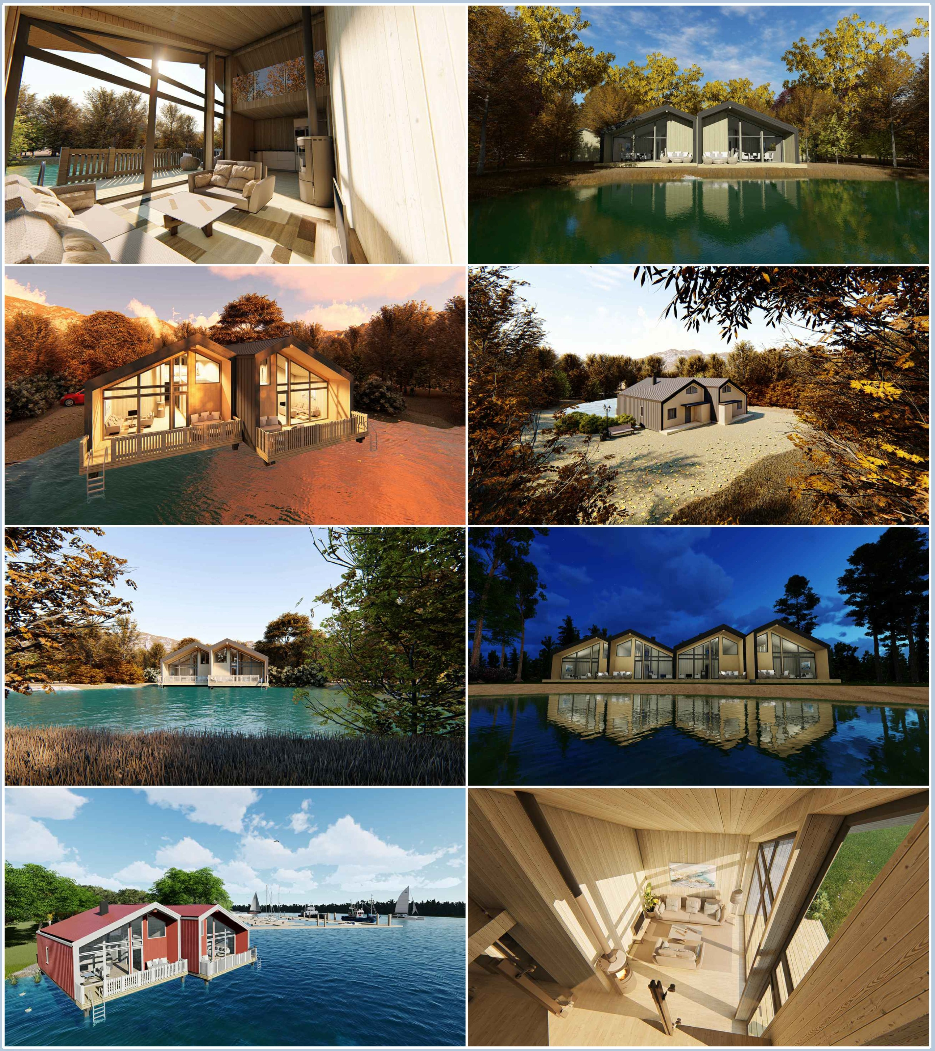

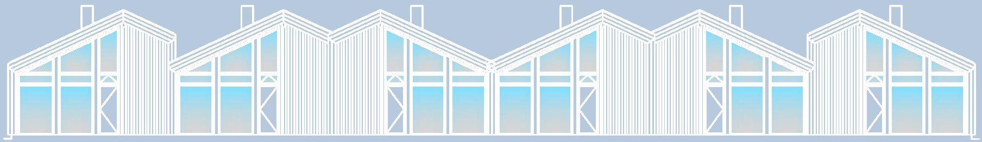
•

Startfromnotes:

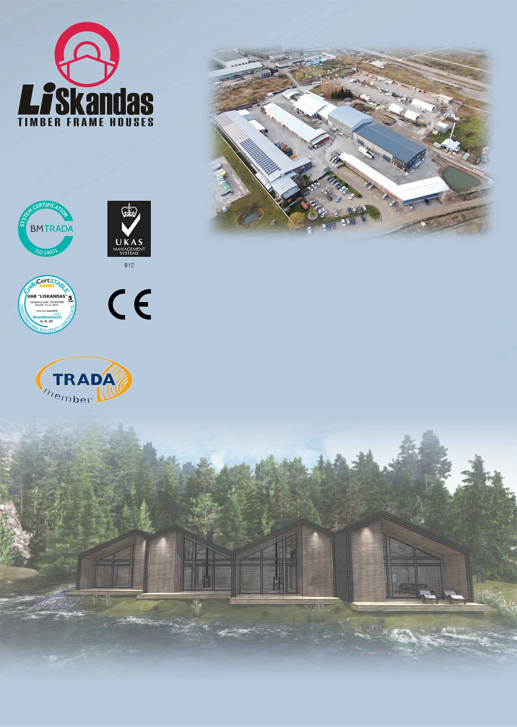

WeareNorwegian-Lithuaniantimberframedhouse manufacturingcompanybasedinLithuania.Webuildwood framedhousesaccordingtotraditionalbuildingtechniques updatingmodernmaterialswhicharerapidlychangingwith
today'sdemandforquality.Ourcompanyhasgrownsince 1997'sandtodaywehaveprojectsforbuildingframedhousesall
aroundEurope:mainlyinNorway,Sweden,GreatBritain,Italy, Iceland,andBalticcountries.Ourhousebuildingtechnique expandedtosuitedifferentclimateanddifferenttraditions.The beautyofourworkisthatweexchangebuildingtraditionsin
differentcountriesandtrytoachievethebestsolutiontobuilda
house,suitabletoourclient.

